1st Shelford & East Bridgford Scout Group


Welcome Pack



Table of Contents
Welcome.....................................................................................................................................................3
Scouting......................................................................................................................................................3
The Group and Sections .................................................................................................................4
Group Contacts ......................................................................................................................................4
Programme of Recurring Events..............................................................................................5
The Promise.............................................................................................................................................5
Uniform .......................................................................................................................................................6
Badge Work .............................................................................................................................................7
Subscriptions..........................................................................................................................................7
Trips and Activities ............................................................................................................................7
Photographs / Video Footage ...................................................................................................8
Child Protection.....................................................................................................................................9
Squirrel Scouts Uniform and Promise ..............................................................................10
Beaver Scouts Uniform and Promise ................................................................................11
Cub Scouts Uniform, Promise and Law........................................................................... 12
Scouts Uniform, Promise and Law...................................................................................... 13
Explorer Scouts Uniform, Promise and Law................................................................. 14
Gift Aid Declaration Form ......................................................................................................... 15
Photographic & Video Footage Permission Form ................................................... 16

Information/Contact Form ......................................................................................................17
Welcome
Your child has expressed a wish to join us at the 1st Shelford & East Bridgford Scout Group. This pack will provide you with basic information regarding Scouting and the Group. There are a number of forms at the end of this pack and we would appreciate it if you would fill these in and return them to us. The purpose of these forms is explained within the pack.
Scouting
The Scout Movement is a global co-educational youth organisation, the largest in the world, with over 60 million Members in 216 countries and territories.
In the UK Scouting is organised through The Scout Association and which has a clear purpose:
To help young people achieve their full physical, intellectual, social and spiritual potential as individuals, as responsible citizens and as Members of their local, national and international communities.
The Scout Association offers everyday (and some more unusual!) adventures and activities to over 450,000 young people across the UK.
Scouting is open to all young people aged 4 to 25 of every faith and background as long as they are prepared to make the promise. A number of variations of the promise are available.
There are also plenty of opportunities for adults to become involved as Leaders, Assistants, Administrators and as Group Supporters. If you would like to be involved with our Scout Group then please contact one of the Group’s Leaders.
As a member of our Group we will endeavour to ensure that your child can help to make the world a better place. Scouting makes a positive contribution to society by helping young people to develop as active members of the community who:
• Are self reliant,
• Are caring,
• Are responsible,
• Show commitment.
However most importantly this continual personal development works best when the young people are working in partnership with adults. They do this by:
• Exploring the outdoors,
• Participating in teams,
• Taking responsibility,
• Taking part in the Progressive Training Programme
The Programme is a continuous progression of training, activities and awards that covers
everything that young people do in Scouting from the age of 4 to 25.
Whilst the activities they take part in will depend on their age, each Section gives young
people the opportunity to learn by doing. The main programme areas are:
• Outdoor and Adventure
• Global
• Community
• Fit for Life
• Creative
• Beliefs & Attitudes
Leaders are trained to deliver this programme, ensuring our young people stay safe while they enjoy themselves and learn.
The Group and Sections
The Group currently consists of a Squirrel Drey, a Beaver Colony, a Cub Pack, a Scout Troop and an Explorer Unit.
• Squirrels 4 and 5 years old, meet on Wednesdays between 4.45pm & 5.45pm
• Beavers 6 to 8 years old, meet on Wednesdays between 6.00pm & 7.00pm
• Cubs 8 to 10 ½ years old, meet on Tuesdays between 6:00pm & 7.15pm
• Scouts 10 ½ to 14 years old, meet on Wednesdays between 7:15pm & 9:00pm
• Explorers 14 to 18 years old, meet on Tuesdays between 7:30pm & 9:00pm
There is some flexibility in age ranges in all sections.

All sections meet in the Scout Headquarters which is situated on Butts Close, off Kneeton Road, East Bridgford, NG13 8PG. Access to the headquarters is either via the footpath opposite the red Telephone Box on Main Street or via the footpath by St Peter’s School on Kneeton Road.
All group members that progress to the Explorer Unit are more than welcome to help out as “Young Leaders” with any of the other sections.
The Group can always benefit from assistance, either as a Leader, helper or a member of the
Group’s Board of Trustees or even as occasional specialist skills instructor, passing on skills or hobbies.
If you would like to help, in any capacity, please contact us.

Group Contacts
Group Scout Leader:
Steve Cumberland
Mobile Phone number: 07990 571515
Home Phone number: 01949 842658
Email:steve.cumberland@notts-scouts.org.uk
Squirrels
Chloe Smith Email: burgesschloelouise@gmail.com
Beavers
Laura Lakin Email : lauralakin51@gmail.com
Cubs
Lizzie Frankling Email: lizziegough@gmail.com
Scouts
Francis Meylan Email: fmeylan@btinternet.com
Explorers
Steve Cumberland Email: steve.cumberland@notts-scouts.org.uk or
Francis Meylan Email: fmeylan@btinternet.com or
Group Chairman
Chris Evans Email: chrisevans1200@gmail.com

Programme of Recurring Events
Whilst every year is different, there are a number of events that tend to occur at the same time each year.

Section | When | Activity
Cubs/Scouts/Explorers | Jan | Winter Camp
All | Jan/Feb | Group Quiz Evening
All | March/April | Soup’n’Spud Fundraiser
All | Sunday nearest to 23rd April | St George’s Day Parade
All | May Bank Holiday | Group/District/County Camp
All | Saturday nearest to 29th June | East Bridgford Show
All | Sunday nearest to 29th June | Feast Sunday Church Parade
Scouts/Explorers | Late July/Early August | Summer Camp
Scouts/Explorers | Oct | District Night Hike
All | Friday nearest 5th Nov | Village Fireworks
All | Nov | Soup’n’Spud Fundraiser
All | Nearest Sunday to 11th November | Remembrance Sunday Parade
All | December | Group Carol Service

The Promise
Our Scout Group is an “open Group”. This means that as long as your Child meets the general requirements for membership of the Scout Association they are welcome within our Group.
To become a member of the Scout Association and our Group your child will be asked to make a promise at an Investiture Ceremony. This will normally be done at a Section Meeting, however it can be carried out at any event. We will always try and make this a very special event for your child but it is your child’s investiture and will only be carried out when they were ready. Investitures may be delayed so that they can be carried out at a special event e.g. at camp. Parents are encouraged to come to these ceremonies.
The Promise that they make will be dependent on the section that they are joining. The
general promise for each section is attached; the promise can be altered to take account of religious beliefs; nationality and / or special needs.
In the Promise your child will undertake to either “do their duty to God” or to “love God”. Whilst we are not attached to any particular religious body the Group does attend the Remembrance Day and Feast Day parades. We also hold an annual carol service and, when possible, attend the local church when at camp.
Their Leader can generally answer any questions that you or your child may have with regard to the promise.

Uniform
Details of uniform for each section, and the location of badges are attached.
At weekly meetings we would normally expect your child to attend in uniform from the waist up. However, for specific activities full or suitable uniform activity-wear may be more suitable.
Guidance on the expected uniform for each activity will be provided with details of the
proposed event or activity.
• Squirrels Red sweatshirt and Group neckerchief
• Beavers Turquoise sweatshirt and Group neckerchief
• Cub Scouts Dark green sweatshirt and Group neckerchief
• Scouts Teal green smart shirt, Scout belt and Group neckerchief
• Explorers Beige smart shirt, Scout belt and Explorer neckerchief
The Scout Association produce dark blue uniform “activity” trousers. Navy blue coloured
Regatta walking trousers are very similar. For events where full uniform is required these
activity / walking trousers or dark grey / black “school” type trousers / skirt would be more
than adequate. For Scouts and Explorers, full uniform also includes a brown leather Scout belt.
The Group neckerchief is Royal Blue and Gold. These are provided by the Group. The Explorer neckerchief is also Royal Blue and Gold but has a Red, White & Blue edging.
For activity wear there is a choice of optional polo shirts, available in Red for Squirrels, Turquoise for Beaver Scouts, Green for Cub Scouts and Scouts and Beige for Explorers and Leaders.
Uniform can be purchased online from shop.scouts.org.uk.

Badge Work
Members of all ages work towards attaining awards and activity badges. From Circus Skills and Street Sports to Imagination and Public Relations, there is a wide range of choice of Activity Badges for all Sections. Hobbies that your child already has can also be used to help both “activity badges” and progressive training awards.
There are “Joining In” awards which are presented with the numbering indicating how many years the Member has regularly attended and participated in the balanced programme across the whole Scout Movement. Only the highest numbered badge is worn.
Each section has a range of Challenge Badges. These can either be done individually or in groups. On completion of a number of these your child can earn the relevant Chief Scouts Award, the highest award earned worn on their uniform.
• Squirrel Scouts –Chief Scouts Acorn Award
• Beaver Scouts – Bronze Chief Scouts Award
• Cub Scouts – Silver Chief Scouts Award
• Scouts - Gold Chief Scouts Award
• Explorers – Platinum & Diamond Chief Scouts Award. They can also work towards their King’s Scout and Duke of Edinburgh Awards.
When your child is ready to move onto the next section there are moving on awards for each section.
Occasionally your child may be asked to undertake things at home to go towards badge-work.

Subscriptions
Our annual membership fee is currently £120 per year, per child. This membership fee is not only used to cover the day to day running costs of each section but also the amounts payable to both our Scout District and Scout Headquarters to cover Insurance, Leader Training etc. Our other costs are covered by our fund-raising activities throughout the year.
As a Charity we can reclaim tax on any donations which we receive (and this includes Annual Membership Subscriptions) so long as the person making the payment has signed a simple Declaration stating that this is their wish and that they pay sufficient tax to cover the amount of the payment. In return, the Inland Revenue will refund 25p for every £1.00p paid! This means that every £120 that is paid by this method is worth £150.00p to our Group.
At the end of this welcome pack is a simple form which, when completed, can be returned to any of our Leaders.
As you will see the form is in three sections.
Section 1- This allows you to choose the frequency of your payment – you may wish to make a one off payment of £120.00p or you may prefer to pay £10.00p monthly, £30 quarterly or £60 half yearly.
Section 2 – Please sign this simple declaration allowing us to reclaim the tax on your payment – if you don’t the money will just be lost. If only one partner pays tax then that partner should complete this form. If both partners pay tax then either one can fill in the form – but not both.
Section 3 – This is the Bank Standing Order. As I mentioned earlier, payments can be made Monthly, Quarterly, Half Yearly or Yearly - it is up to you. Similarly, you can select the date on which the payment is made to suit your own circumstances.
If you have more than one member in the Group, please indicate this at the foot of the form as shown.

Trips and Activities
When organising trips or activities we often have to impose a cut-off date for responses. This is generally due to the need to purchase tickets, to complete all of the necessary risk assessments and to make arrangements with the “home contact” for the event.
We ask that parents make every effort to reply before the deadline set. Similarly, if subsequent to your child being accepted on a trip or activity, they are unable to attend please let us know as soon as possible
For some activities, there may be a restriction on the number able to attend. In this case, we will operate a first come – first served policy.
There may also be times when we look to parents to help with transport.
We appreciate that funds can sometimes be tight. If you need a bit of help towards the cost of camps etc or if you wish to spread the payments, please have a quiet word with one of the Leaders.
It is our policy never to exclude any young person from any activity because of cost.

Photographs / Video Footage
The various sections regularly take part in a wide range of activities, organised at a Group,
District or County level. Many of these involve challenging activities, which the youngsters
involved often like evidence of to prove that they have taken part.
In addition, images of the youngsters enjoying themselves can be extremely useful for
publicity purposes, internally (e.g. for use on the Group Facebook pages), externally (sent to local
newspapers and on display boards, group website etc.
Photographs and video footage of the youngsters may also be used as a training aid (both adult and youngsters) or as validation of adult training.
At Group events, it is relatively easy for the Leaders in charge to take suitable and agreeable
photographs of the children involved. At larger events, such as District or County events, it is
not necessarily possible for the Leader to dictate what photographs might be taken or the
specific end use of the photographs. However, as the photographs would be taken as part of a
Scouting event they would need to comply with The Scout Association’s Child Protection Policy,
as would photographs or video images taken during Group events.
Please ask if you have any questions concerning this. If we wish to use photos for any other
purposes, we will seek your permission. There is a form at the rear of pack, please fill it in as
appropriate, sign to say that you accept it and return to one of the Leaders.

Parent Rotas
We do ask parents to help out occasionally by being part of a Parent rota. These rotas are particularly helpful for our Squirrel, Beaver and Cub Leaders.
As a helper on the parent’s rota you will be asked to assist with games and craft activities and support the young people to participate in activities. You will be guided by our Leaders and will be a valuable part of the team
If you are unable to do a date you have selected please swap with another parent and please let us know.
Younger children may accompany you on your rota evening but they remain your responsibility at all times.

Child Protection
The Scout Association's policies, rules, code of behaviour, advice on Child Protection and safety policy are there to ensure our young people stay safe whilst the Programme of activities that we provide is fun, exciting and challenging. Most importantly we must also make sure that all activities undertaken are safe.
It is the policy of The Scout Association (and therefore of the Group) to safeguard the welfare of all Members by protecting them from physical, sexual and emotional harm.
The Scout Association is committed to:
• Taking into account in all its considerations and activities the interests and well-being of young people;
• Respecting the rights, wishes and feelings of the young people with whom it is working;
• Taking all reasonable practicable steps to protect them from physical, sexual and emotional abuse, and
• Promoting the welfare of young people and their protection within a relationship of trust.
All adults aged eighteen or over, no matter what their role or involvement within Scouting, are responsible for putting this policy into practice at all times.
All Leaders and regular helpers have been subjected to, and passed, an enhanced Disclosure & Barring (DBS) check. In addition, all leaders have to have up to date Safety and Safeguarding Training and achieve a basic first aid qualification during their training.
However, accidents occasionally can happen, consequently in order to comply with The Scout Association’s own health and safety policy’s we require certain information regarding emergency contacts (next of kin, emergency contact numbers etc.). If this information changes e.g. change of address or phone number, please let us know. A Personal Information form is attached.
During activities and trips this contact information, including parent or guardian contact information, will be collated and controlled by the event organiser. They will nominate someone to be the events nominated “contact”. If it is necessary to get in touch with you during the event, it is likely to be this person who will contact you.
Further information and consent forms may be required for specific activities.
The Group can cope with members that have special needs, however we do need to know of any special requirements, allergies etc that your child may have.
All information provided is kept in complete confidence. It is normal for us to ask for a new
form to be filled in when your child moves sections to ensure that we have up to date
information. The only people outside of the Group to have access to any of this information
would be a nominated “contacts” during trips or activities.

Squirrel Scouts Uniform and Promise

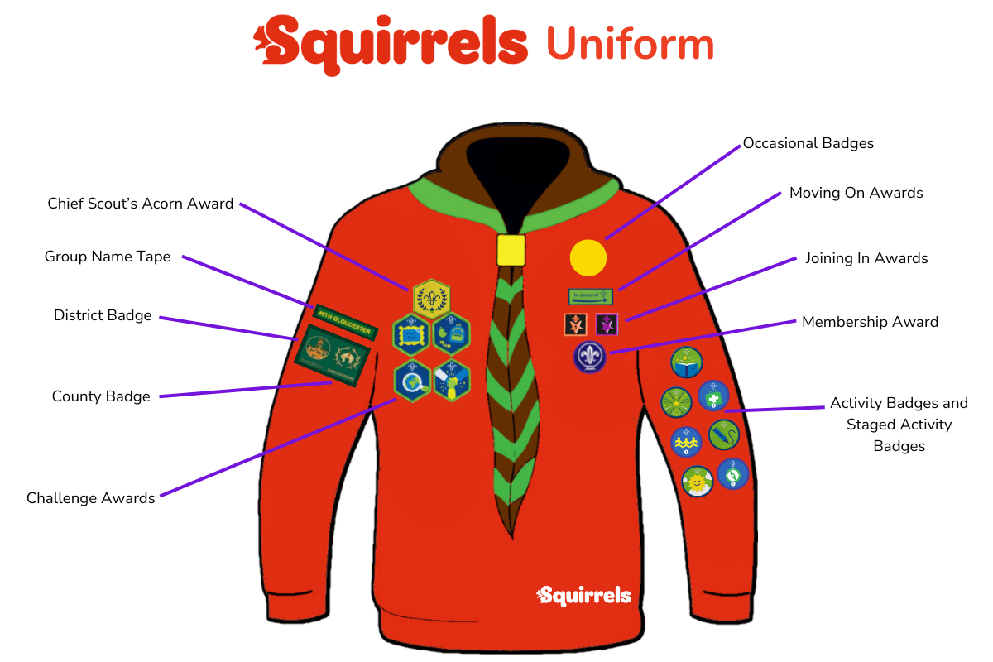

The Squirrel I promise to do my best
Scout Promise To be kind and helpful
And to love my World

Beaver Scouts Uniform and Promise
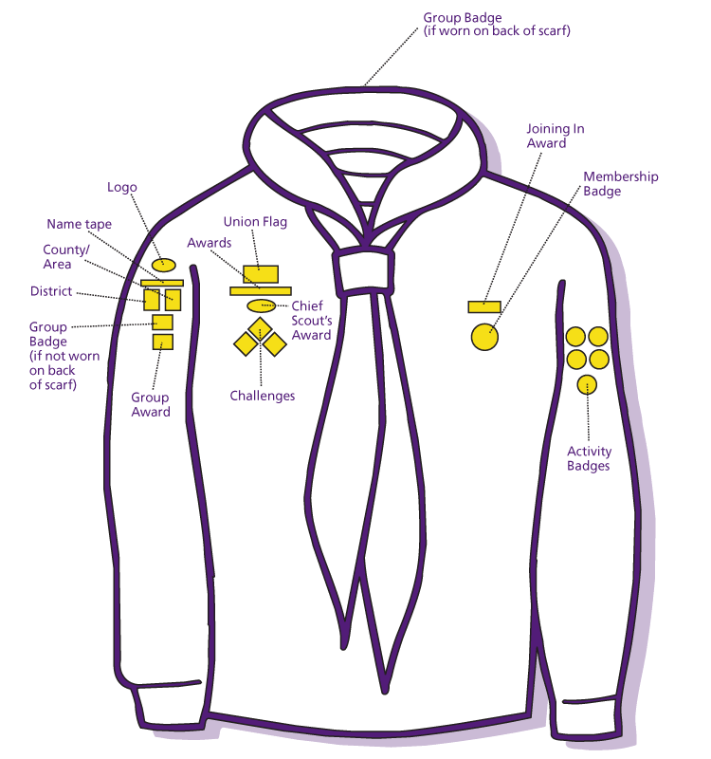
The Beaver I promise to do my best
Scout Promise To be kind and helpful
And to love my World

Cub Scouts Uniform, Promise and Law
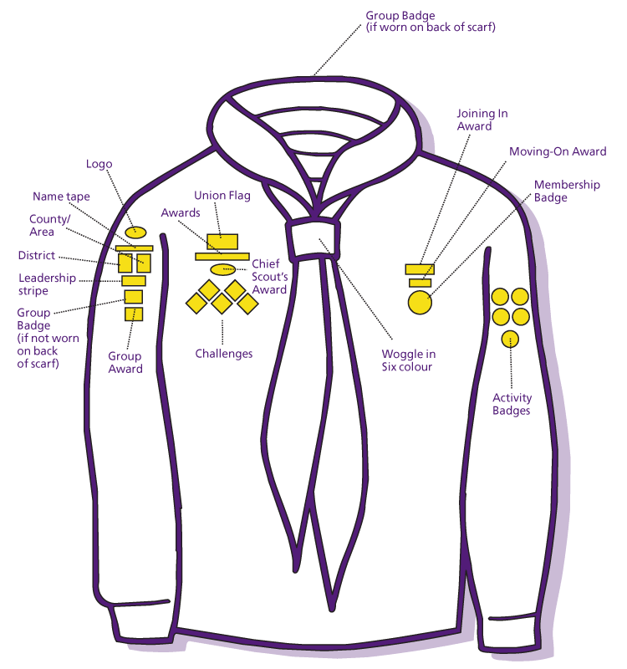

The Cub Scout I promise that I will do my best
Promise To do my duty to God and to the King,
To help other people
And to keep the Cub Scout Law
The Cub Scout Cub Scouts always do their best
Law Think of others before themselves
And do a good turn every day.
Scouts Uniform, Promise and Law
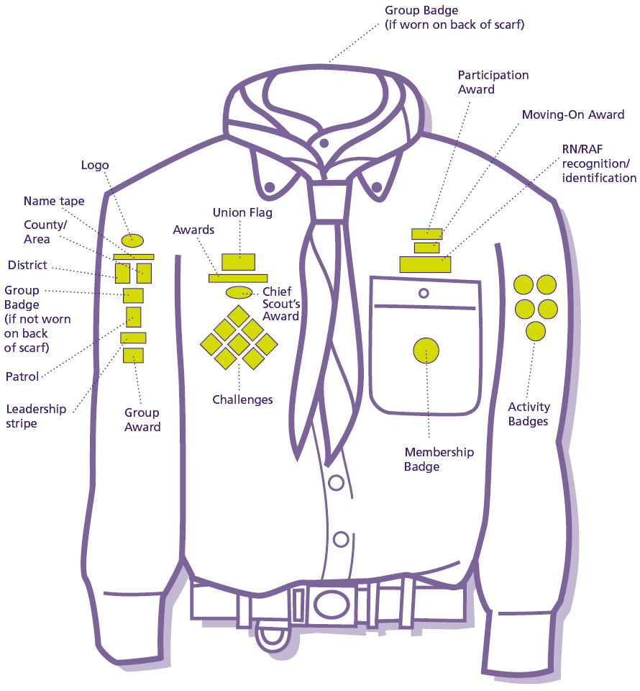
The Scout On my honour, I promise that I will do my best,
Promise To do my duty to God and to the King,
To help other people,
And to keep the Scout Law
The Scout 1) A Scout is to be trusted.
Law 2) A Scout is loyal.
3) A Scout is friendly and considerate.
4) A Scout belongs to the worldwide family of Scouts.
5) A Scout has courage in all difficulties.
6) A Scout makes good use of time and is careful of possessions and . property.
7) A Scout has self-respect and respect for others.
Explorer Uniform, Promise and Law
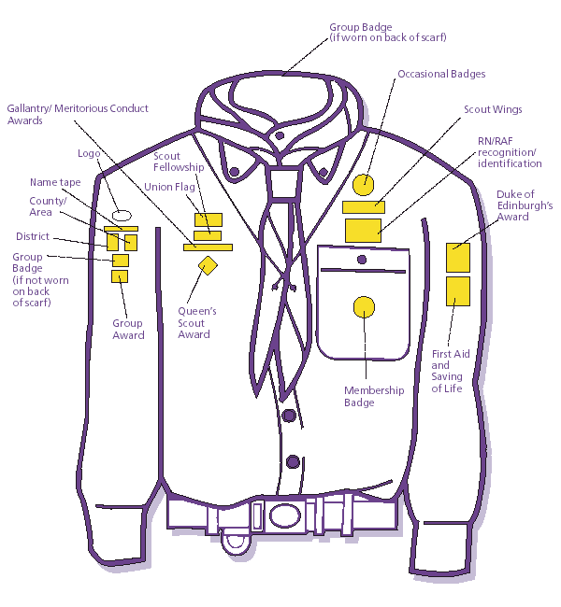
The Explorer On my honour, I promise that I will do my best,
Promise To do my duty to God and to the King,
To help other people,
And to keep the Scout Law
The Scout 1) A Scout is to be trusted.
Law 2) A Scout is loyal.
3) A Scout is friendly and considerate.
4) A Scout belongs to the worldwide family of Scouts.
5) A Scout has courage in all difficulties.
6) A Scout makes good use of time and is careful of possessions and . property.
7) A Scout has self-respect and respect for others.

1st Shelford & East Bridgford Scout Group

If our Group is to reclaim Tax on your Giving, only ONE person should complete this Form
Membership | from…………..………………………….(Parent name) for………………………………………...(Child name)
[ Home Address ] …………………..……………………..……………………………..……………
[ Home Address ] ……………………………………………..……… [ Postcode ] …………...…..
I should like to give | £ …………….… | ( Totalling £ 120.00p per year per child )
each month / quarter / half year / year [ Please circle preference ]
starting on ………..… ( Day ) ………………….………. ( Month ) ……….…..… ( Year )
>> The next section - ‘Declaration’ - should only be completed if you pay Tax <<<
Declaration to allow our Group to reclaim Tax on your giving

Tick this box if you want 1st Shelford & East Bridgford Scout Group to reclaim tax on all your donations in the future from the date of this declaration and in the past 4 years. Currently 25p for every £1 donated.

I am a UK taxpayer and understand that if I pay less Income Tax and/or Capital Gains Tax than the amount of Gift Aid claimed on all my donations in that tax year it is my responsibility to pay any difference. Please notify the Treasurer if you want to cancel this declaration, change your name or home address or no longer pay sufficient tax on your income and/or capital gains.
[ Signature ] …….…………………….……..……….. [ Date ] ………………...……

Please complete the Standing Order Mandate below

>>> Please do NOT detach the Bank Standing Order below <<<

Bank Standing Order to 1st Shelford & East Bridgford Scout Group

Please pay to:  For : | National Westminster Bank plc,  1st Shelford & East Bridgford Scout Group | Sort Code 60-02-41  A/C Number 08821739

I have arranged the Bank Standing Order payments by phone or internet banking, and these payments will start on................................
*This Standing Order replaces any existing Standing Order payable to the same recipient with effect from the above starting date.
*This Standing Order is in addition to my existing Standing Order payable to the same recipient. (Please delete as appropriate)

Photographic & Video Footage Permission Form
I acknowledge that during the course of scouting events (weekly meetings, days out, camps, etc) photographs and / or video footage may be taken and could be used for any of the purposes outlined below.
I also acknowledge that on larger events photographs and / or video footage may be taken that the Group’s Leaders have no control over.
I understand that all photographs and / or video footage taken by or on behalf of Scouting events will comply with The Scout Associations Child Protection Policy. However, the Group has no control over the photographs and / or video footage taken by Third Parties and their proposed end use for the photographs and / or video footage.

Use | I give my permission | I withhold my permission
To be provided to you after events
Recruitment of Members or Leaders
As a training aid and validation of Leader training
Internal publicity (Group Newsletter, promotion of future events to members of the Group etc.)
External publicity (submission to Local newspapers, ‘Scouting Magazine’ Website etc)
To be shown at Group events / on the Groups notice boards in the Scout Hut.

Signature: …………………………………………………………………

Name (Printed)……………………………………………………………

Date:…………………………………….

Personal Information Form Please complete and return.
Personal details  Child’s Name:  Known as:  Date of birth: _______ / _______ / _______  Religion:  Ethnicity letter: ________, disability __________ (see over) | Data Protection  The Scout Movement in the United Kingdom is a membership organisation. To enable it to operate and communicate with its members it is necessary to maintain records about them. This includes keeping details of name, address, date of birth and contact telephone numbers. We also keep records of progress through Scouting - badges gained etc. Information held in our group may be shared from time to time within Scouting, including the headquarters of the Association in its annual census.  New legislation came into force in May 2018 2000 which covers the protection and processing of personal data. Adults and young people have the same rights under the Data Protection Act 1988 which covers paper-based as well as computer-based information. Information that we hold will only be used in connection with your child’s membership of the Scout Movement and will not be passed to third parties outside the Scout Movement without your consent. You may ask to see the information that we hold. If you have any concerns about this policy please talk to a leader.  It is important that we always have your correct address and telephone number for use in emergencies. If you do move to a new house or change your contact details (including e-mail address) please tell us.  * Your e-mail address will be added to our mailing list so that we can keep you up to date electronically
Contact details
Parent/guardian names:
Hobbies/interests/skills/occupation of parents/guardians:

Address:

Postcode:
Phone number: (__________)
Mobile number:
e-mail*:
Medical details
Doctor’s name:
Doctor’s address:

Doctor’s phone number: (__________)
Special needs – medical, diet, allergies, etc:

Vegetarian: Yes / No NHS Number:
Tetanus: Did they have the pre-school booster? Yes / No
Background
School:
Anything else you think we should know…

I consent to my child named above becoming a member of 1st Shelford & East Bridgford Scout Group and accept the data protection and publicity policies that have been explained to me.
Signature of parent/guardian: __________________________
Ethnicity & disability information
Scout headquarters now asks us to provide ethnicity and disability information for our members. The information you provide will be stored on your child’s record and sent to Scout headquarters on our annual census return. It will help the Scout Association match their data more closely with the UK National Census and gain a more accurate picture about whether or not Scouting truly reflects our local area.
If you have any concerns about providing us this information please speak to a leader.
Ethnicity
The ethnicity information uses the standard categories that are used in the national census. Choose the one that is appropriate and enter the letter on the personal information form.
White | A | English/Welsh/Scottish/Northern Irish/British
White | B | Irish
White | C | Gypsy or Irish Traveller
White | D | Any other White background
Mixed | E | White and Black Caribbean
Mixed | F | White and Black African
Mixed | G | White and Asian
Mixed | H | Any other mixed/multiple ethnic background
Asian | I | Indian
Asian | J | Pakistani
Asian | K | Bangladeshi
Asian | L | Chinese
Asian | M | Any other Asian background
Black | N | African
Black | O | Caribbean
Black | P | Any other Black/African/Caribbean background
Other | Q | Arab
Other | R | Other
 | S | Parent/individual refused to provide data
Disability
0 | No disability declared
1 | Dyslexia
2 | Autistic spectrum
3 | Blind/partially sighted
4 | Deaf/hard of hearing
5 | Wheelchair user/mobility difficulties
6 | Personal care support
7 | Mental health difficulties
8 | Multiple disabilities
9 | Unseen disability eg diabetes, epilepsy, asthma etc
10 | A disability not covered above

